

Advanced Membership
Standard Operating Procedure and Portfolio Submission Form

National Back Exchange

Responsible Person
Sarah Thornton

Authors
Ali Roper, Membership Director
Rosie Beckford, Association Coordinator

Contents
1. Version Control Summary 3
3. Introduction 4
4. Membership Categories 4
5. Benefits of Advanced Membership 5
6. Portfolio Standards 5
7. Portfolio 6
8. Criteria of Evidence 6
9. Portfolio Evidence 8
10. Advanced Member Application Process 11
11. Successful Application 12
12. Unsuccessful Applications 12
13. Appeals Procedure 12
14. Renewal of Advanced Membership 13
15. References 13
Appendix 1. Contents Spreadsheet 14
Appendix 2. NBE Advanced Member Criterion and Evidence Submission 15
Appendix 3. How to Submit Your Portfolio: Embed Evidence into the Criterion and Submission Form 17

1. Version Control Summary

Date | Version no. | Summary of changes | Consulting group / person
2020 | 1.0 | New Standard Operating Procedure and Application for National Back Exchange Advanced Membership | P Shirliker, Membership Secretary
May  2024 | 2.0 | Reviewed and updated as NBE is a Charitable Incorporated Organisation as of 29th March 2023 | A Roper, Membership Director  S Thornton, Chair  R Beckford, Associations Coordinator

2. Background History
The Registered Membership category was introduced in 2005 and allowed for Direct entry on completion of a Post graduate qualification based on the Inter professional Curriculum (NBE 1997). This category was renamed in 2011 to Advanced Member.

To promote the aims of National Back Exchange (NBE) Charitable Incorporated Organisation (CIO) it was recognised that this process needed to be updated and submission of a portfolio of evidence is required rather than a ‘standalone’ qualification to demonstrate achievement of the standard required of an Advanced member.

3. Introduction
National Back Exchange recognises that our individual competencies are gathered from a wide variety of backgrounds, industries, and experiences.

As the arena of Moving and Handling continues to evolve it is anticipated that many members of NBE will be able to progress to Advanced Membership.

It is also recognised that Members may require guidance and support in this endeavour and therefore a Mentor (a current NBE Advanced Member) can be provided at any point in the process.

Advanced Members will be vital to the continuance of NBE’s role of providing expertise, advice, and guidance to inform the evidence base for best practice in Moving and Handling activity - wherever it takes place.

Ongoing research is essential to provide an up-to-date evidence base for safer Moving and Handling practice.

There is an expectation that those applying for Advanced Membership will embrace research as an integral component to maintaining their current level of competence and to increasing their level of expertise.

Whilst some are involved in formal research projects on a national or international level, many members routinely participate in research activity as an individual practitioner, in their own organisation or local to their geographic location such as that undertaken within their NBE affiliated group.

4. Membership Categories
Currently there are two levels of National Back Exchange membership: Standard and Advanced.

- Standard membership provides members with access to a wide range of support tools, up to date news and information, access to educational events and opportunities to network with other practitioners.
- Advanced Membership provides additional benefits, as described in Section 5, alongside those of standard membership.

To apply for Advanced Membership, you must:
- Be a standard member of National Back Exchange.
- Register interest to proceed to Advanced Membership.
- Submit a Portfolio to evidence that meets the criteria outlined in Section 7.

5. Benefits of Advanced Membership
5.1 Benefits to the Individual
Advanced Membership of NBE:
- Demonstrates competence in the field of Moving and Handling.
- Evidences commitment to professional development.
- Is a criterion benchmark for employment.
- Provides an opportunity to:
  - Provide Mentor support to new Advanced Member applicants.
  - Become an Advanced Member Review Panel member.
- Offers eligibility to join Loughborough Alumni Research Forum (LARF).
- Provides use of Advanced Member National Back Exchange logo.

5.2 Benefits to National Back Exchange
Having a cohort of Advanced Members of NBE:
- Elevates the professional standing of NBE.
- Confirms the knowledge and skill set of its membership.
- Identifies and promotes NBE as the ‘go to’ Organisation for local and national advice and guidance in the field of Moving and Handling.
- Influences standards of practice and Key stakeholder partnerships.
- Provides a mentorship framework for less experienced members.

5.3 Benefits to Employers
Employment of an NBE Advanced Member provides:
- Assurance of the provision of competent moving and handling advice.
- Compliance with regulatory requirements.
- Meets local and national occupational standards.
- Evidence to meet inspectorate body expectations.

6. Portfolio Standards
The standards required in the portfolio submitted are aligned to the ten components of the National Back Exchange Standard in Practice: Competence Pathway for Practitioners.

Criterion 1. Behavioural Sciences
Criterion 2. Biological sciences
Criterion 3. Biomechanics and Ergonomics
Criterion 4. Health Policy and Practice Issues
Criterion 5. Legal and Professional Responsibilities
Criterion 6. Management of Change
Criterion 7. Principles of Health Promotion and Education
Criterion 8. Principles of Research and Evaluation
Criterion 9. Risk Management
Criterion 10. Practical Moving and Handling (within the last three years)

7. Portfolio
Each portfolio must include:
- A summary of the applicant’s service area, roles, and responsibilities.
- A contents spreadsheet (Appendix 1)
- Evidence for seven of the criteria listed above in section 6:
- Six criteria from criterions 1-9, and
- Core criterion 10, which is mandatory for all portfolios.

8. Criteria of Evidence
Criterion 1: Behavioural Sciences
Evidence in this section should provide the important perspective of the psychosocial influences which impact on people at work, both as individuals and as part of an organisational work culture.

A focus on organisational psychology and a perspective of human behaviour under varying work conditions is required.

This should be incorporated into approaches to management of people at work demonstrating an understanding of the differing ability of people to manage their own health and illness at work.

Criterion 2: Biological Sciences
Demonstrate a basic knowledge of the normal anatomy and physiology of the living human body.

Sufficient depth of understanding of the structure and function of the human musculoskeletal system is required to enable the practitioner to recognise potential hazards to musculoskeletal health.

Criterion 3: Biomechanics and Ergonomics
The concepts of biomechanics and ergonomics are central to an understanding of human movement at work and the potential for people to build up musculoskeletal stress from their work activities. Ergonomic intervention is the first consideration in solving moving and handling problems.

Provide evidence demonstrating an awareness of:
- The effects of postural instability and the forces that can act on the musculoskeletal system whilst moving and handling.
- Cognitive load and organisational factors which impact on work activities.
- Analysis of the task regarding people as central to socio-technical work systems.

Criterion 4: Health Policy and Practice Issues
Knowledge is required of the factors both within and beyond the organisation that influence provision and delivery of health and social care.

An understanding should be demonstrated as to how political and social policies affect practice.

Criterion 5: Legal and Professional Responsibilities
Study of this area should develop knowledge and confidence to facilitate working practice and systems of work which comply with the provisions of the law. An understanding of UK law, the principles of negligence, breach of statutory duty and duty of care, vicarious liability, and the framework for claims for compensation is required. Issues of professional accountability and confidentiality in practice and skills of report writing, documentation and record keeping should also be included.

Provide evidence outlining Legal and Professional Frameworks in relation to Moving and Handling whether of people or inanimate loads. This could include elements of a strategic risk system or approach such as audit or service evaluation, adverse event / Incident investigation reports.

Criterion 6: Management of Change
There are numerous change management models in use across all sectors which consider people at work and the design of working systems.
Change management can occur at many levels with the fundamental principles remaining similar.

Demonstrate use of a change management model to outline how you have instigated change in a field of work related to moving and handling.

Criterion 7: Principles of Health Promotion and Education
Health promotion and health education is required to prevent ill health and encourage healthy behaviours.
There are a number of theories and models of health promotion and health beliefs.

Demonstrate how your practice is involved in prioritising, planning and evaluating health promotion programmes from an organisational and environmental perspective.

Criterion 8: Principles of Research and Evaluation
Theoretical aspects of scientific enquiry and the philosophical and sociological perspectives of quantitative and qualitative research methodology should underpin a working knowledge of a range of methods.

Evidence how you undertake and / or interpret research activity including critical appraisal of the literature to inform best practice.

Criterion 9: Risk Management
Risk Management in this context is concerned with development of a framework to support reduction of moving and handling related risk to a reasonable level. This may include development of documentation, risk assessment strategy, provision of equipment, environmental considerations, education, and training inputs etc.

Demonstrate how you have developed and implemented aspects of a risk management strategy.

Criterion 10: Practical Moving and Handling
Moving and Handling is a practical skill which should be supported by an understanding of human movement principles and how these can be applied to a range of situations.

Delivery of Moving and Handling teaching and training requires sufficient knowledge of the theoretical and practical skills involved to facilitate others’ learning.

Provide evidence of moving and handling education / training programmes which include a number of different practical skills. This must include lesson plans with SMART learning outcomes and any additional resources used.

9. Portfolio Evidence
9.1 Each criterion must:
- Include a minimum of three primary evidence items (Section 8)
- Demonstrate a minimum of 30 hours of activity.
Note: Activity time can include:
- The time spent undertaking the activity, including preparatory research, background investigation or subsequent learning.
- Any identified lessons learnt, implementation into practice or identified changes made to the strategic direction of the Organisation / Service.

9.2 Evidence
Evidence is partitioned into two types: Primary and Supporting. Supporting evidence validates the primary evidence or demonstrates activity hours.

Examples of primary evidence:
- Participation in research activity can be evidenced by tutor feedback from assignments and/or dissertation submissions, from referencing published work, acknowledgement of authorship or participation, presentation of findings, content of speaking engagements etc.
- Certificate denoting current registered healthcare qualification which includes behavioural sciences as part of the curriculum and evidence of behavioural sciences being incorporated in CPD submitted for revalidation / re-registration.
- Certificate denoting level 5 qualification which incorporates biological sciences as part of the curriculum.
- Reports detailing support given to individuals commencing or returning to work following musculoskeletal injury.
- Risk assessments outlining physical stressors as well as stressors of work and workload.
- Level 5 qualification in Biomechanics / Ergonomics.
- Lesson plan for delivery on training which includes content of relevant criterion.
- Reflection activity related to the learning outcomes following attendance at a programme on relevant criterion.
- Report on biomechanical analysis of a moving and handling task.
- Ergonomic assessment of a department / task specific to moving and handling activities
- Documented analysis using a validated ergonomic tool.
- Published research article on a relevant topic.
- Evidence of contribution to:
  - Patient pathway development
  - Organisational policy for Moving and Handling
  - Cross discipline working.
- Copy of an Expert Witness report
- Root Cause Analysis / Accident investigation report
- Conference presentation: Abstract submitted, copy of presentation and delegate feedback.
- Reflection activity following attendance at a Conference session or practical workshop which outlines how this knowledge / skill has been applied in your practice.
- Assignment or module feedback (Level 5 or above).
- Evidence of participation in a research study.
Please note – the above are examples and the list is not exhaustive.

Examples of supporting evidence:
- A lesson plan may be submitted as primary evidence. The training the lesson plan relates to may be a full or half day session, or a module that takes 1 hour to deliver. However, this course or module may have been trained numerous times across the three-year window. Supporting evidence may be a training schedule, which demonstrates the number of times the training course or module has been delivered. This evidences activity hours.
- A Certificate of Attendance on formal programmes of study or informal learning activities may submitted as primary evidence. However, this demonstrates only attendance and not learning. Supporting evidence may be a reflective account to demonstrate what you learned, what learning needs have been highlighted and how your learning has been translated into practice.
- A project report may be submitted as primary evidence. However, the project may have been a joint venture from a team of people. Supporting evidence may be a testimonial to what your roles and responsibilities were within the project.

9.3 Evidence Items
Each evidence item must:
- Be saved with a:
  - Descriptive title to reflect the evidence, for example Lesson Plan – Biomechanics module.
  - Reference Number – for example evidence for criterion 10 should be referenced as 10a, 10b, 10c etc.
These should be cross referenced on the Contents Spreadsheet.
- Include the applicant’s name, date, and designation (assessor, author, trainer, investigator etc)
- Be anonymised to comply with data protection regulations and must not identify individuals other than the applicant’s.
- Clarify which criterion it relates to.
- Only be used against one criterion; this is to ensure that sufficient depth and range is included.
- Be dated within the previous three-year period of the submission date.
- If a qualification was achieved prior to this, it will only be accepted if the qualification is:
  - Is subject to a revalidation/ re-registration process and the member remains ‘live’ on a professional register.
OR
  - Demonstrates how the qualification content is integrated into moving and handling practice (within the last three years).

10. Advanced Member Application Process
10.1 Application
Access the NBE website and download the Advanced Membership
Standard Operating Procedure and Portfolio Submission Form.

Complete the registration form: Membership Application ⇽ NBE Advanced Membership | National Back Exchange on Glue Up

An acknowledgement of receipt will be sent by the Administration function within seven working days.
If you have indicated that you require support of a Mentor during this process you will be contacted to arrange this.
Complete your portfolio submission form and upload documentary evidence for each criterion selected to Appendix 2. See Appendix 3 for instructions on how to embed evidence into the Criterion submission form.
Send completed standard operating procedure and portfolio submission form to admin@nationalbackexchange.org.
An acknowledgement of receipt will be sent by the Administration function within seven working days.
10.2 Processing of Portfolio
A panel of suitably qualified reviewers (current Advanced Member(s) of NBE) will be allocated and given access to your portfolio of evidence.

Each panel member will independently review your portfolio against set criteria and will seek advice, guidance, and clarification from the Membership Director and NBE Board of Trustees if required.

If Panel Member(s) determine that there is insufficient relevant Portfolio evidence they will contact the Membership Director, or designated member of the Membership Team to discuss any additional evidence which could be forwarded for inclusion.

10.3 Governance
The Membership Director, or designated member of the Membership Team will act as Internal Moderator to ensure reliability and validity of the process. Evidence will be handled in line with General Data Protection Regulations and will be returned on completion of the application process.

10.4 Completion
The Membership Director will report Portfolio review decisions to the Board of Trustees.

10.5 Timeframe
It is anticipated that the timeframe requirement from the point of submission of your portfolio through to ratification and awarding of Advanced Member status will be up to maximum of three months.

This timeframe makes allowance for sourcing the review panel, life events, holidays and sickness absence and other unforeseen circumstances.

11. Successful Application
Once your Portfolio has been ratified you will be informed and provided with:

- A Certificate conferring Advanced Member status signed by the current NBE Chair.
- The NBE Advanced Member Logo.
(Please refer to the NBE Name and Logo Usage Policy).
- Inclusion on the Advanced Member list on the NBE website / Column / Newsletter / Social Media platforms (subject to your permission).

Your Portfolio will be removed from the NBE drive. Your Contents spreadsheet will be retained for recording purposes.

12. Unsuccessful Applications
Support mechanisms in the form of access to a Mentor and advice and guidance from the NBE Board of Trustees and Membership Director throughout the process should result in few unsuccessful applications.

If an application is unsuccessful the applicant will be informed by the Membership Director, or designated member of the Membership Team of their right to appeal.

13. Appeals Procedure
An appeal against an unsuccessful application must be made:
- Within 30 days of the date of notification of unsuccessful application
- Directly to the Chair of NBE at Chairman@nationalbackexchange.org

The Chair will appoint an Appeals Panel per case. This will consist of the current NBE Chair, and two other Advanced Members, none of whom will have been previously involved with the application.

The Appeals Panel will consult with the original Portfolio review panel to investigate the nature of the appeal and agree a decision.

The Chair will inform the appellant of the outcome of the appeal in writing and this decision is final.

A report will be made to the Board of Trustees on the result of the Appeal with lessons learned and any recommendations to change in procedure or practice required. This report will be included in the agenda of the subsequent Board of Trustee meeting.

Resubmission of an Advanced Member application will not be accepted until a minimum of six months has elapsed. This is to allow for any development required to ensure a successful subsequent application.

14. Renewal of Advanced Membership
Renewal of membership of NBE is required annually. Advanced Members are required to complete the Endorsement of Continuing Advanced Membership (ECAM) form every three years.

15. References
National Back Exchange (1997) The Inter-Professional Curriculum Framework for Back Care Advisers, Towcester: National Back Exchange.

Appendix 1. Contents Spreadsheet

You can create your own contents spreadsheet, using the example below, or use the template provided. The contents spreadsheet service three purposes:
Planning tool
As you collect your evidence, record what criterion you anticipate it will cover. This will provide an instant visual of the range of current evidence, where your evidence gaps are, and how many hours of activity you have. It will also avoid duplication of evidence.
Portfolio navigation
Your contents spreadsheet will create a ‘map’ of your portfolio for the Review Panel to navigate. A brief explanation of what the evidence item is and what it evidences, will provide the Review Panel members with context.
Administration
Your contents spreadsheet will be used to record decisions and any comments by the Review Panel members. Once you achieve Advanced Membership your portfolio will be removed from the National Back Exchange drive. The content spreadsheet will be retained for our records.
Example:
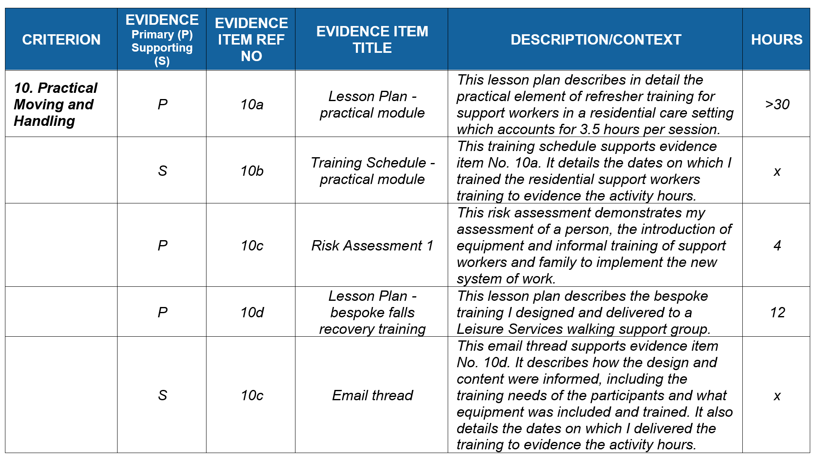

Appendix 2. NBE Advanced Member Criterion and Evidence Submission

Name of Applicant:

NBE Membership No:

Contact Details:
- Email address
- Phone Number

Submission Date:

CRITERIA | EMBEDDED EVIDENCE
Summary of service area, role, and responsibilities

Contents Spreadsheet
Criterion 1  Behavioural Sciences  (30 hours) | 1
Criterion 1  Behavioural Sciences  (30 hours) | 2
Criterion 1  Behavioural Sciences  (30 hours) | 3
Criterion 2  Biological Sciences  (30 hours) | 1
Criterion 2  Biological Sciences  (30 hours) | 2
Criterion 2  Biological Sciences  (30 hours) | 3
Criterion 3  Biomechanics and Ergonomics  (30 hours) | 1
Criterion 3  Biomechanics and Ergonomics  (30 hours) | 2
Criterion 3  Biomechanics and Ergonomics  (30 hours) | 3
Criterion 4  Health Policy and Practice Issues  (30 hours) | 1
Criterion 4  Health Policy and Practice Issues  (30 hours) | 2
Criterion 4  Health Policy and Practice Issues  (30 hours) | 3
Criterion 5  Legal and Professional Responsibilities  (30 hours) | 1
 | 2
 | 3
Criterion 6  Management of Change  (30 hours) | 1
Criterion 6  Management of Change  (30 hours) | 2
Criterion 6  Management of Change  (30 hours) | 3
Criterion 7  Principles of Health Promotion and Education  (30 hours) | 1
 | 2
 | 3
Criterion 8  Principles of Research and Evaluation  (30 hours) | 1
 | 2
 | 3
Criterion 9  Risk Management  (30 hours) | 1
Criterion 9  Risk Management  (30 hours) | 2
Criterion 9  Risk Management  (30 hours) | 3
Criterion 10  Practical Moving and Handling  (30 hours) | 1
Criterion 10  Practical Moving and Handling  (30 hours) | 2
Criterion 10  Practical Moving and Handling  (30 hours) | 3

Appendix 3. How to Submit Your Portfolio: Embed Evidence into the Criterion and Submission Form
Save the Criterion and Evidence Submission (Appendix 2) with your name and date.

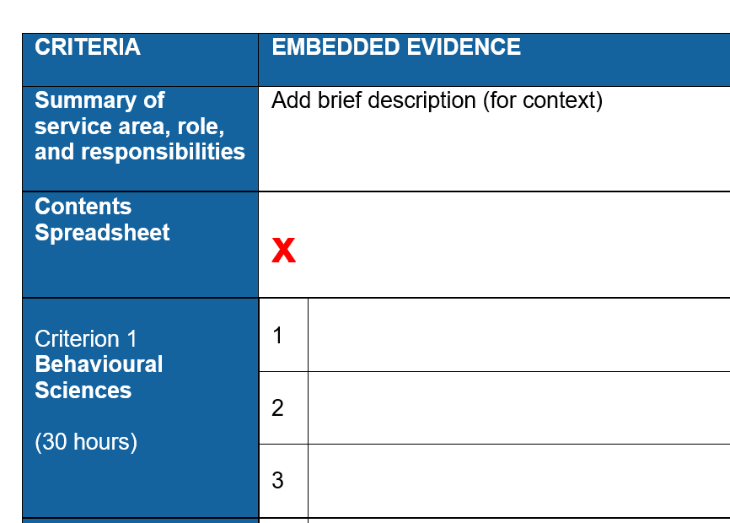

Ensure that the curser is in the relevant section of the application form.

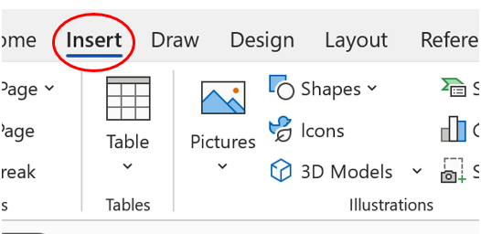

3. Choose ‘Insert’ tab on the task bar

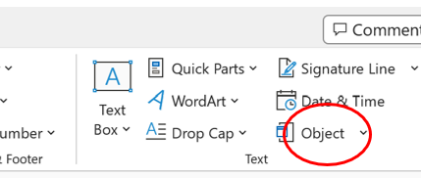

4. Choose ‘Object’ from insert task bar

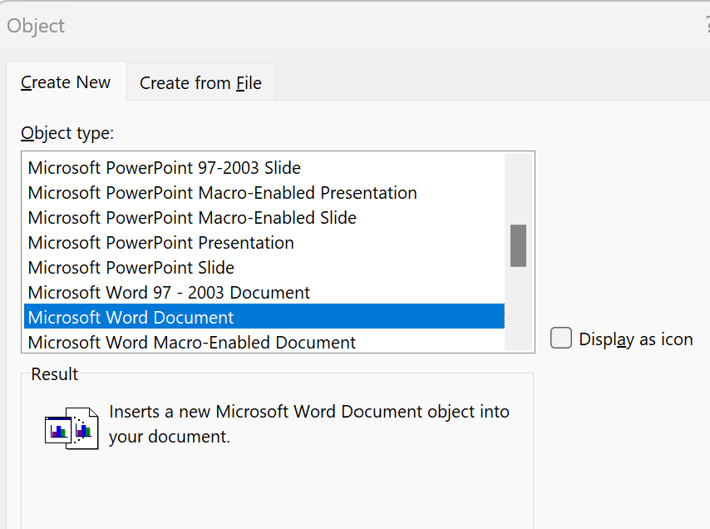

5. Choose ‘Object type’ from drop down menu i.e., Microsoft Word Document, Microsoft Excel Worksheet etc

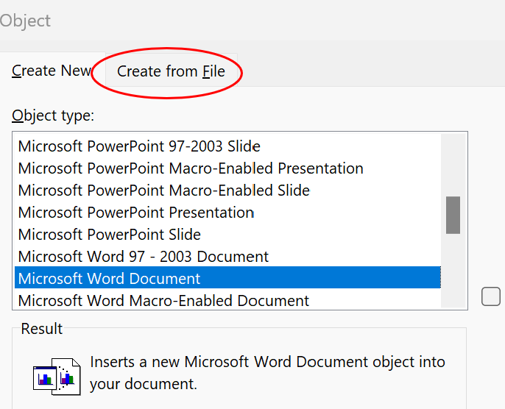

6. Choose ‘Create from file’.

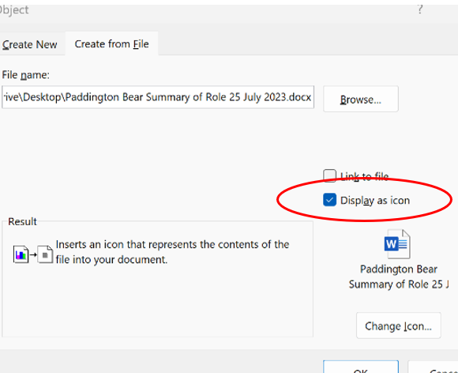
7. ‘Browse’ to choose document to embed. Click ‘insert’.

8. Choose ‘Display as icon’. Ok.

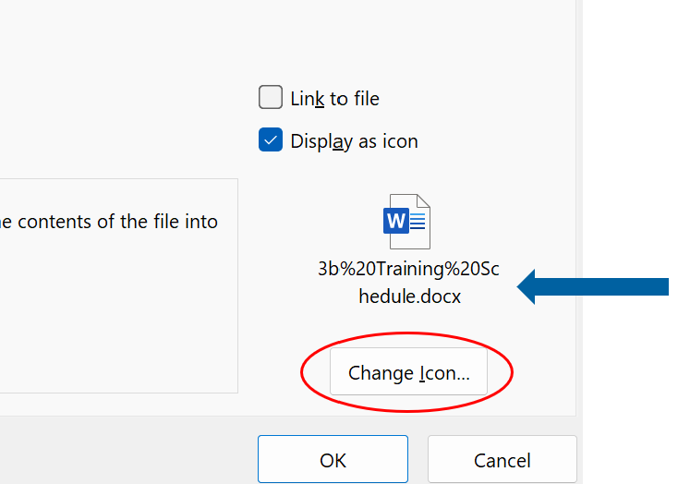

NB. If the evidence item title needs amending, click ‘change icon’ and amend title in ‘caption’ box.

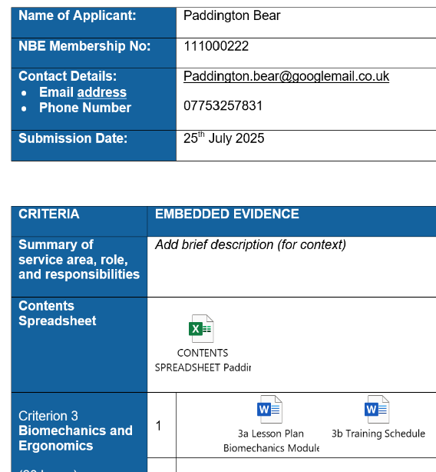

Embed each evidence item into the relevant place.

Save your application form as you go along.

